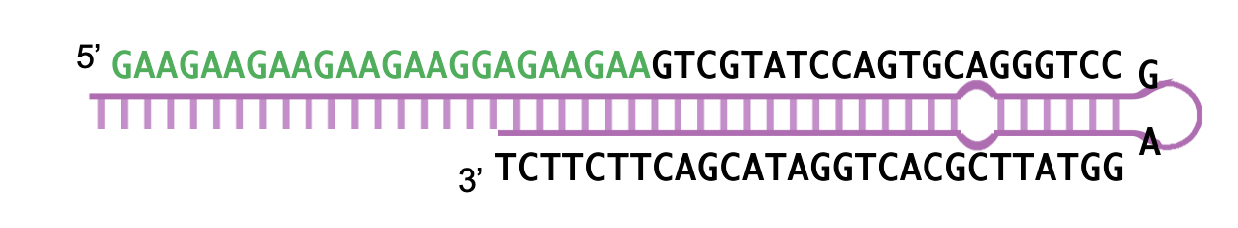

**Figure S1**. The stem-loop primer. The sequences in green correspond to mature tae-miR69 and in black to stem-loop primer.

**Figure S2**. The expression level of PST130_11106 in Vuka (susceptible) and Yr5 (resistance) at different dpi

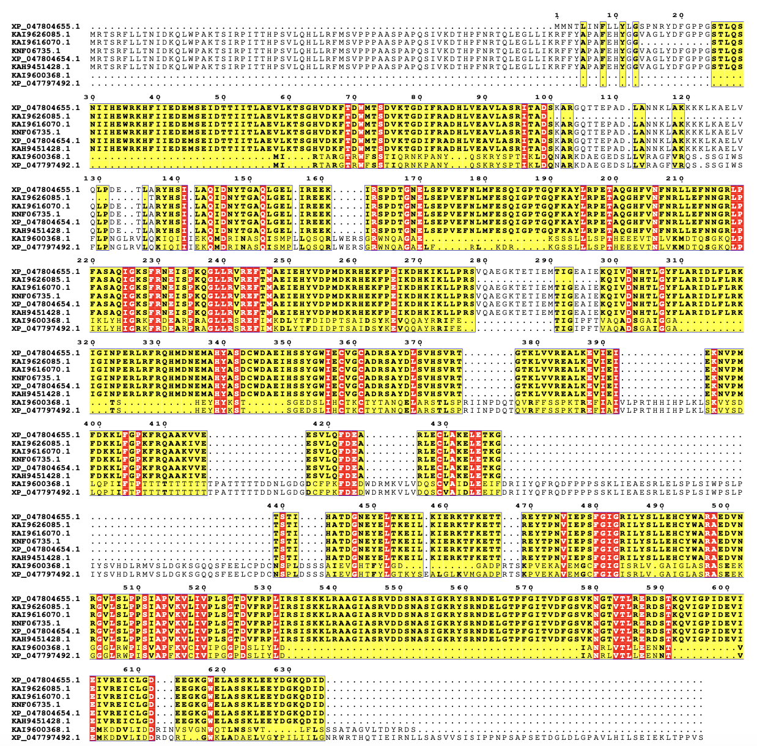

**Figure S3**. Multiple sequence alignment of XP_047804655.1 (PST134EA), KAI9626085.1 (PST-130), KAI9616070.1 (PST-130), KNF06735.1 (PST-130), XP_047804654.1 (PST134EA), KAH9451428.1 (PST134EB), KAI9600368.1 (PST-130), XP_047797492.1 (PST134EA). KNF06735.1 is a candidate target gene of novel-m0039, 159-265 aa is PAZ argonaute-like family domain and 113-119 aa is the domain of matched novel-m0039.